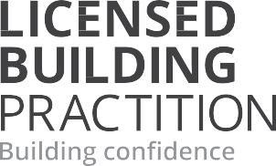

A new code of ethics for Licensed Building Practitioners
In October 2021, the Government announced a new code of ethics for Licensed Building Practitioners (LBPs), with a one-year transition period before it becomes enforceable.
The code of ethics, effective from 25 October 2022, sets behavioural standards for LBPs to give both the industry and consumers clarity on what is expected from LBPs, and to hold them to account.
See the LBP website to learn more about the code of ethics and to access education resources
Code of ethics | Licensed Building Practitioners (lbp.govt.nz)

